**Objective**: Create an SAP Build app that fetches data from a publicly available API.

**Prototype**

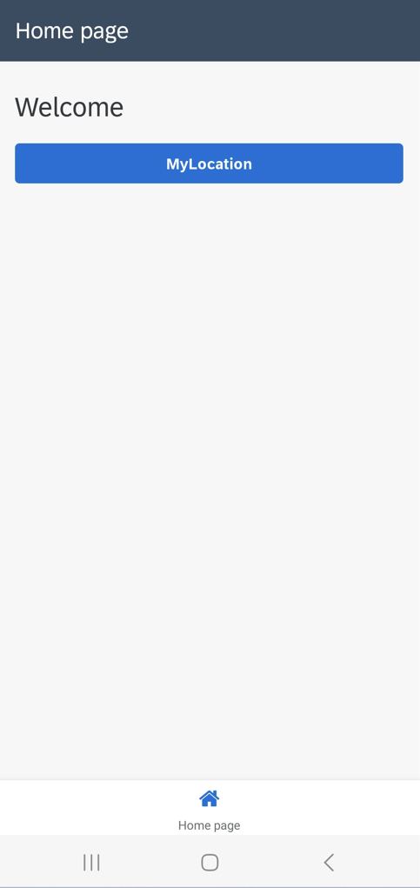 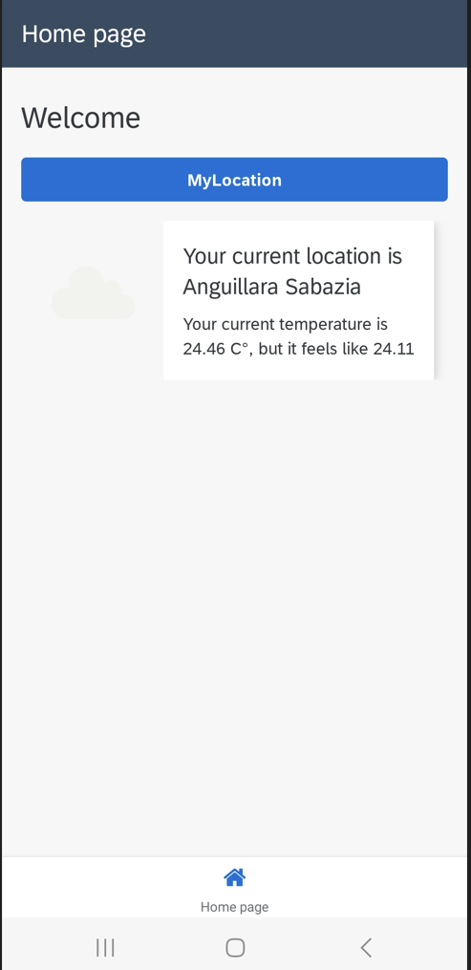

Step-by-step guide to create the weather App.

**DATA CONNECTION**

|  |
| --- |
| **Create a new AppGyver Project** |
| Login to Build Apps SandBox.  Click on create and select Create an application.  Now select Web & Mobile Application | |
| **Create a data resource to fetch using the APIs identified.** |
| The newly created project gets loaded. The first step is to create a Data Resource to fetch data using the Open API identified.  To do that, click on the **Data** option on the menu bar. | |
| Click on Data Tab to open data configurator. | |
| Under SAP Build Apps classic data entities select **REST API direct integration** | |
| API Documentation: <https://openweathermap.org/current>  The following API will be used to complete the base configuration.  https://api.openweathermap.org/data/2.5/weather?lat={lat}&lon={lon}&appid=[{API key}](https://home.openweathermap.org/api_keys)  Complete the **BASE** configuration using the following information:  Resource ID: WeatherApp  Short Description: Weather App  Resource URL: <https://api.openweathermap.org/data/2.5/weather> | |
| Now add a Query Parameter to send API Key to while calling the API from the app.    A new Query parameter gets created. According to the API documentation the API key parameter is “appid”. Update the following properties of the newly created parameter and save.  **Label :** API Key  **Key :** appid  **Is Static :** On  **Value :** ba007f58593d774bb4bea4865969f0cf | |
| Repeat step#6 to create **Units** as a query parameter. Use value **imperial** to show the temperature in Fahrenheit ( we will use a formula function to convert it in Celsius ). | |
| Since we are fetching the weather information of a specific location, we can disable the Get Collection Method.  Click on GET COLLECTION tab and turn it off. | |
| The next step is to configure the **Get Record** Method.  Click on the GET RECORD and remove the prefilled values.    To remove the URL placeholder, click on the placeholder and select REMOVE PARAMETER in the properties tab | |
| The next step is to add query parameters for Latitude and Longitude. Configure it as follows: | |
| Now let’s test the WeatherAPI data resource that has been configured.  Click on the **Test** tab    Click on “X” to bind the data type and select Static number.    Choose Static number    Now enter some values and click on RUN TEST to check the response of the API.    You should see the “Status: ok” and a response from the server. **Now click on SET SCHEMA FROM RESPONSE and save it**.    If you get don’t get the response, please check if you have followed the steps correctly.  With these steps the Data resources will connects the app to the OpenWeather API has been configured.  You can now close the Data Configurator. | |